**Req. 9.2** – An actor who is not authenticated must be able to browse the list of items and navigate to their providers.

Technical details of the computer on which the test has been executed:

* Ram: 8,0 (1x) GB, DDR3 RAM (1,600 MHz)
* CPU: Intel Core i5-4200U
* Disco duro: 240 GB SSD

**Test case description**:

* The unauthenticated user clicks on "Items List" from the menu.
* The unauthenticated user clicks on the link of any provider on the list.

**Maximum workload test case.** 70 concurrent users and 50 of loop count:

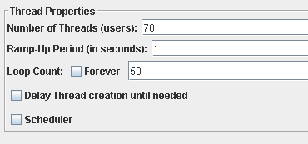

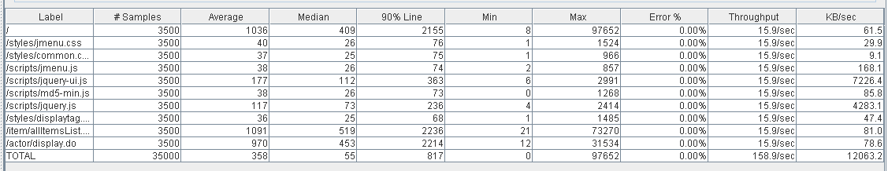

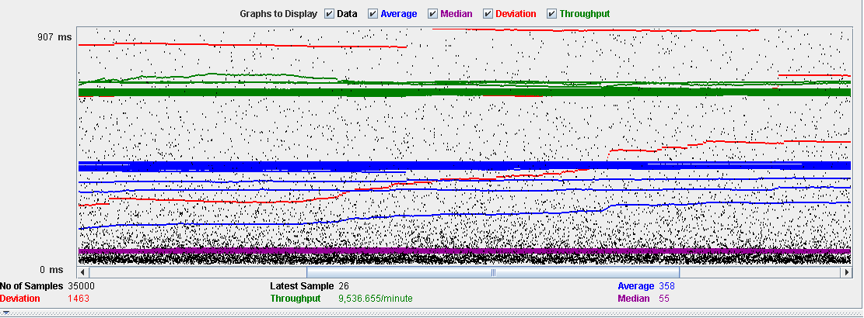

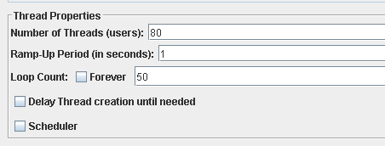**Overload test case:** 80 concurrent users and 50 of loop count:

As we can see in the report if we increase the number of threads the 90% line gets a value too high.

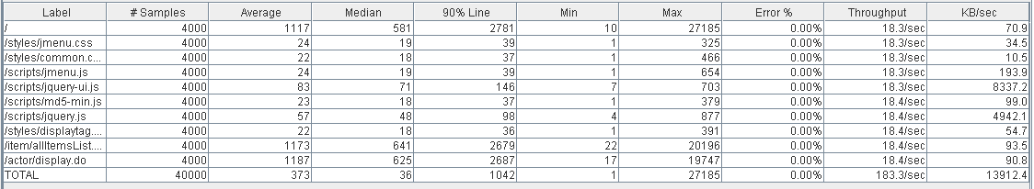

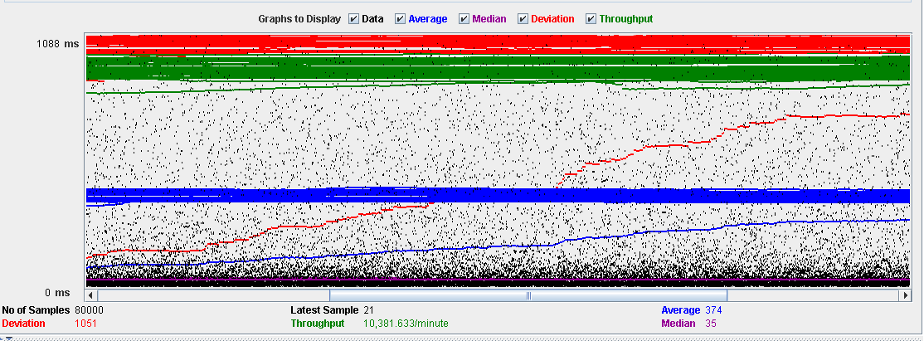

As we can see in the graph below, there is a bottleneck with the CPU. Probably we could improve the maximum workload of the application if we assign more processors to the virtual machine.

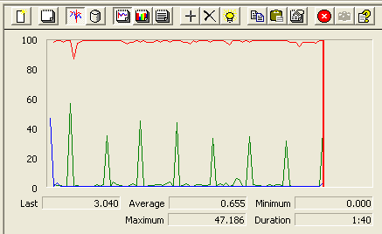

**Conclusion:** The maximum number of concurrent users supported by this test case is 70 and we could improve it by assigning more CPU’s resources to our system.

**Req. 10.1** – An actor who is authenticated as a provider must be able to manage his or her catalogue of items, which includes listing, showing, creating, up- dating, and deleting them.

Technical details of the computer on which the test has been executed:

* Ram: 8,0 (1x) GB, DDR3 RAM (1,600 MHz)
* CPU: Intel Core i5-4200U
* Disco duro: 240 GB SSD

**Test case description**:

* The user logs in as a provider.
* Display her/his profile.
* List her/his items.
* Display item.
* The provider closes session.

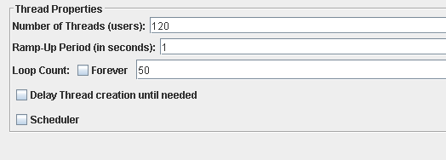**Maximum workload test case.** 120 concurrent users and 50 of loop count:

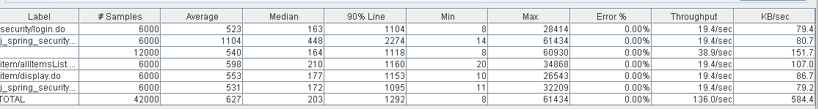

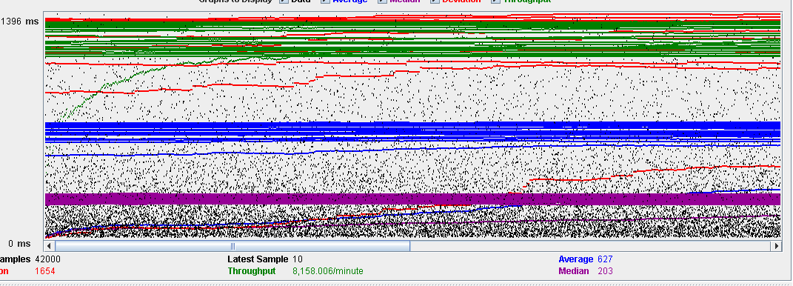

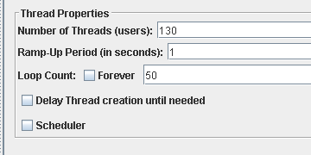**Overload test case:** 130 concurrent users and 50 of loop count:

As we can see in the report if we increase the number of threads the 90% line gets a value too high.

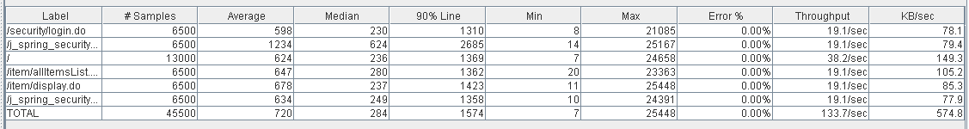

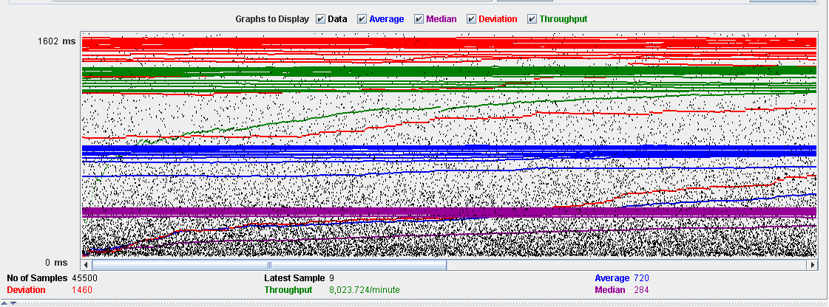 As we can see in the graph below, there is a bottleneck with the CPU. Probably we could improve the maximum workload of the application if we assign more processors to the virtual machine.

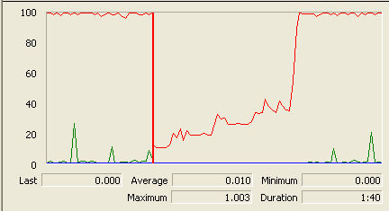

**Conclusion:** The maximum number of concurrent users supported by this test case is 120 and we could improve it by assigning more CPU’s resources to our system.

**Req. 10.1** – An actor who is authenticated as a provider must be able to manage his or her catalogue of items, which includes listing, showing, creating, up- dating, and deleting them.

Technical details of the computer on which the test has been executed:

* Ram: 8,0 (1x) GB, DDR3 RAM (1,600 MHz)
* CPU: Intel Core i5-4200U
* Disco duro: 240 GB SSD

**Test case description**:

* The user logs in as a provider.
* Display her/his profile.
* List her/his items.
* Create new item.
* Delete item
* The provider closes session.

**Maximum workload test case. 25** concurrent users and 50 of loop count:

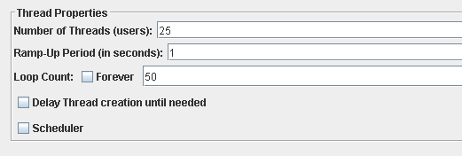

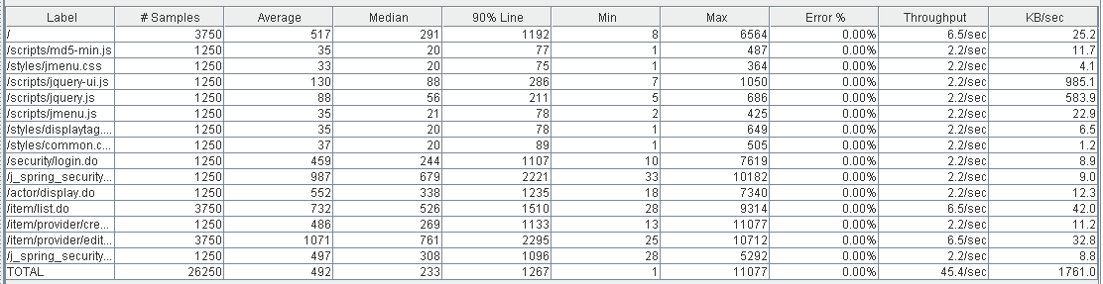

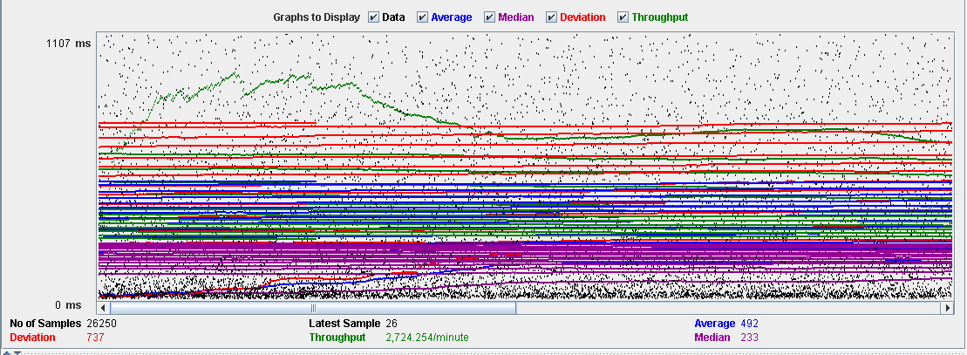

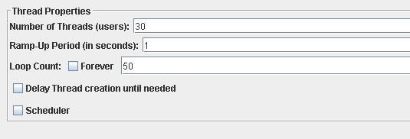**Overload test case:** 30 concurrent users and 50 of loop count:

As we can see in the report if we increase the number of threads the 90% line gets a value too high.

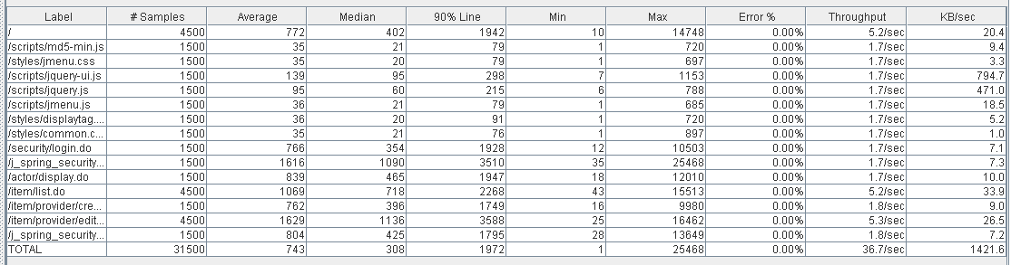

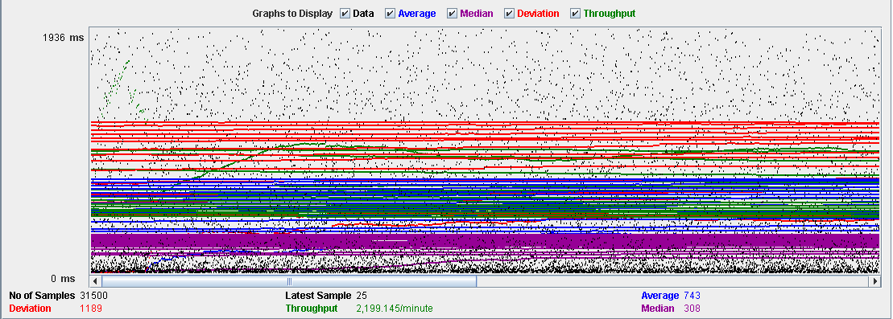 As we can see in the graph below, there is a bottleneck with the CPU. Probably we could improve the maximum workload of the application if we assign more processors to the virtual machine.

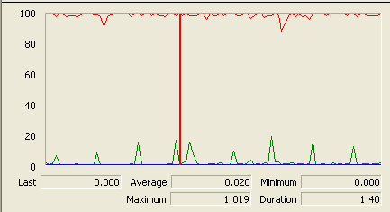

**Conclusion:** The maximum number of concurrent users supported by this test case is 25 and we could improve it by assigning more CPU’s resources to our system.

**Req. 10.1** – An actor who is authenticated as a provider must be able to manage his or her catalogue of items, which includes listing, showing, creating, up- dating, and deleting them.

Technical details of the computer on which the test has been executed:

* Ram: 8,0 (1x) GB, DDR3 RAM (1,600 MHz)
* CPU: Intel Core i5-4200U
* Disco duro: 240 GB SSD

**Test case description**:

* The user logs in as a provider.
* Display her/his profile.
* List her/his items.
* Edit item
* The provider closes session.

**Maximum workload test case.** 120 concurrent users and 50 of loop count:

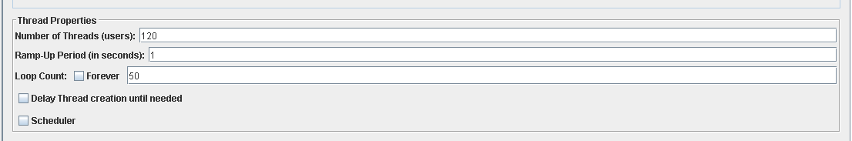

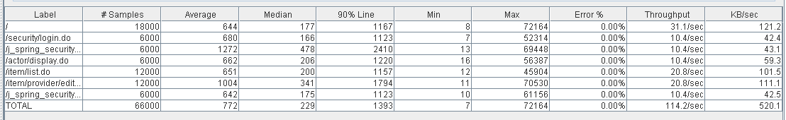

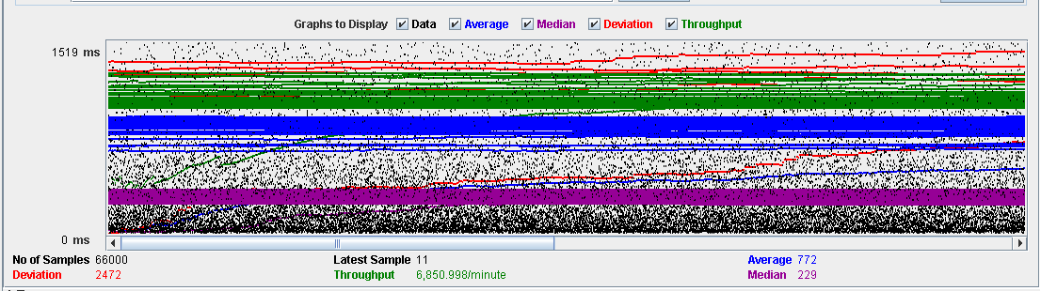

**Overload test case:** 130 concurrent users and 50 of loop count:

As we can see in the report if we increase the number of threads the 90% line gets a value too high.

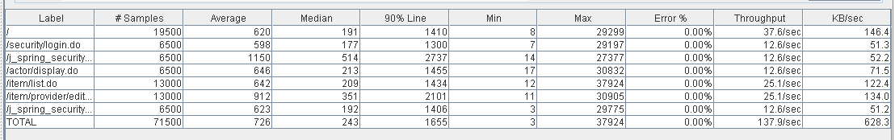

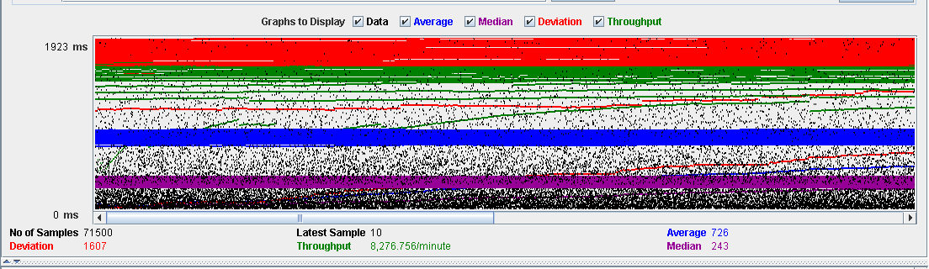 As we can see in the graph below, there is a bottleneck with the CPU. Probably we could improve the maximum workload of the application if we assign more processors to the virtual machine.

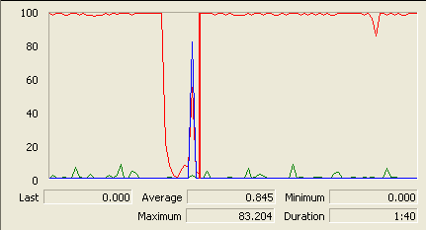

**Conclusion:** The maximum number of concurrent users supported by this test case is 120 and we could improve it by assigning more CPU’s resources to our system.